This is typically going to be the first screen when you turn on your computer.
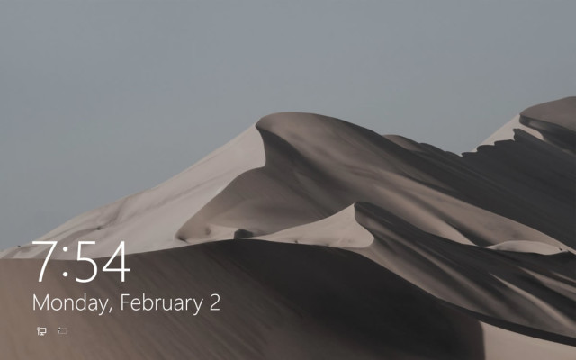
Clicking on the image with a mouse or using the up arrow key will get you to the login screen.
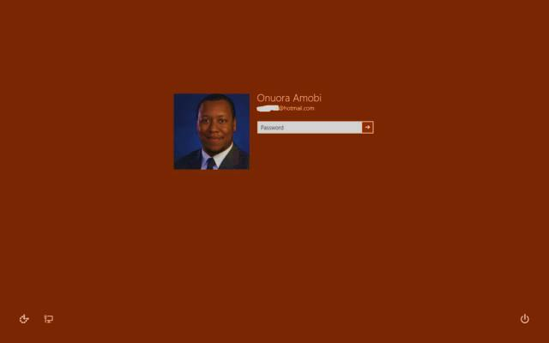
You can enter your password, either a local password or your Microsoft account. The button on the bottom right has the three options for the PC to sleep, shutdown or restart.

What is a Start Menu?
A Start Menu is simply a helpful user menu that can be accessed in Windows 10 by two methods. 1) Pressing the Windows key or 2) Clicking on the Start Button in the bottom left of the screen.

Why do we need a Start Menu?
A Start Menu is simply a quick and helpful collection of useful items that Windows 10 users may want to access, all in one place. It’s a lot more efficient than hunting for each of those items on your own.
Let’s take a look at the different sections of the Start Menu.

User Avatar
On the top right, the Start Menu has a user name and avatar picture showing the current user logged in to Windows 10.

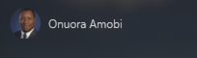

Most Used Items
Right below the User Avatar, we have the items that have been used most frequently:
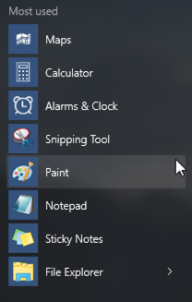

Life at a Glance
The next section on the right is a collection of apps called Life at a Glance.
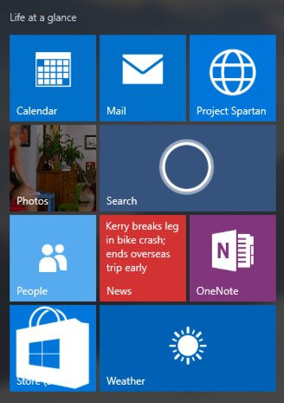
This is a collection of applications that are likely to be core to your use of Windows 10:
  - Calendar Mail Microsoft Edge
  - Photos Search People
  - News OneNote The Windows Store
  - Weather

Play and Explore
This section is to the right of or below “Life at a Glance” and has secondary apps that a user might be interested in:

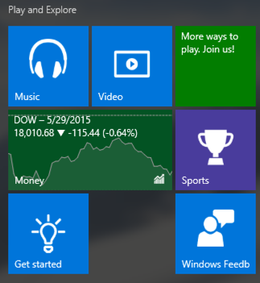
This section has the following items in it.
- Music Video The Xbox App
- Stocks Sports Get Started (a tutorial)
- Windows Feedback

Miscellaneous Grouping
There are four other items on the Start Menu that are miscellaneous but will be used a lot as well.
- File Explorer (for looking for files)
- Settings (Windows Settings)
- Power (Restart, Shut Down)
- All Apps (show a list of all apps)

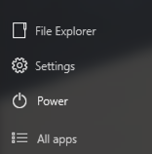

All Apps
When you click on All Apps, it opens up a secondary menu on the left and shows all apps listed in alphabetical order.

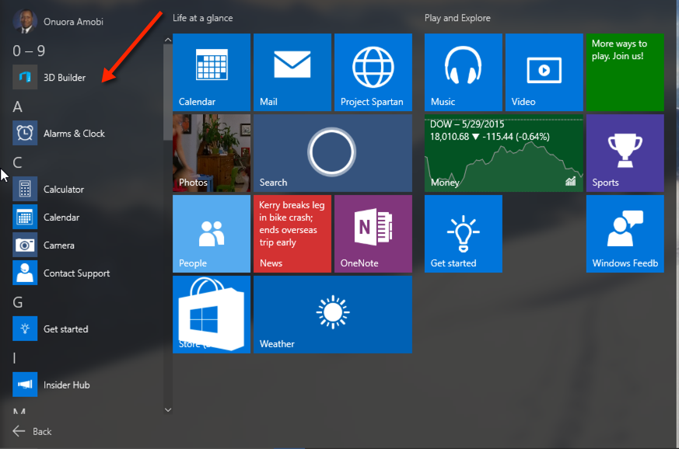

The Start Menu can be configured in Windows 10.
This happens in the settings menu by clicking on Personalization

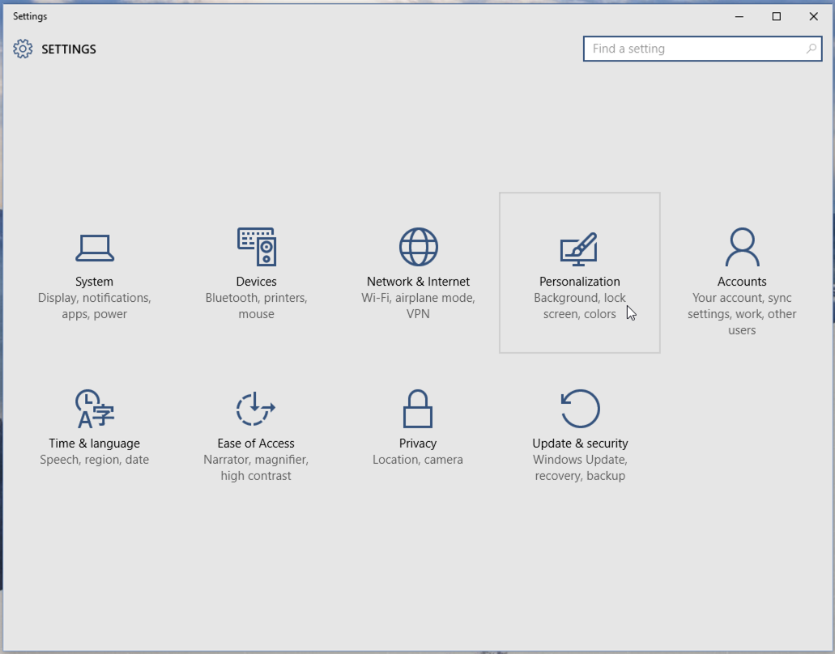
Then click on “Start” in the left menu, as below:
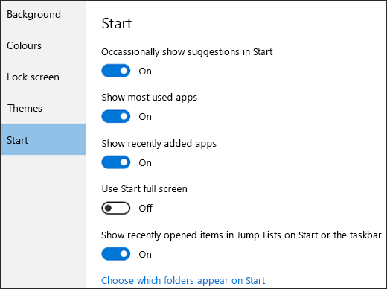

Bottom of Form

A new look for settings
Settings has a new look:
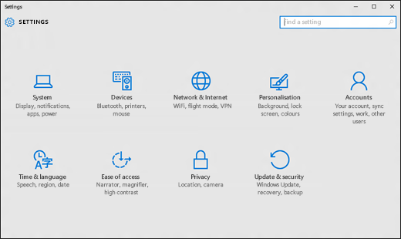
Get to Settings by selecting the Start button, then selecting Settings. From there, browse the categories or use search to find what you’re looking for, including advanced options in Control Panel.
Tip: Change common settings (such as flight mode and WiFi) on the fly from Action Centre on the taskbar.
Top of Form

Changing desktop background and colours
Select the Start button, then select Settings > Personalisation to choose a picture worthy of gracing your desktop background, and to change the accent colour for Start, the taskbar and other items. The preview window gives you a sneak peek of your changes as you make them.
In Background, select a picture, solid colour, or create a slide show of pictures.
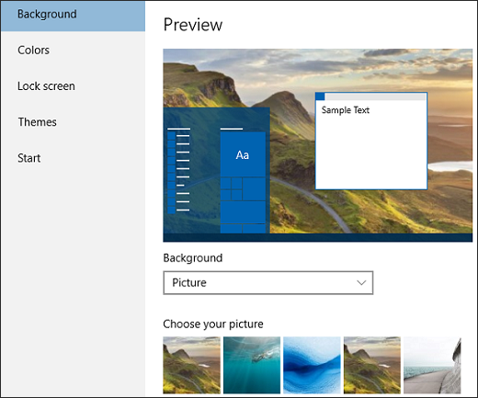
In Colours, let Windows pull an accent colour from your background, or choose your own colour.
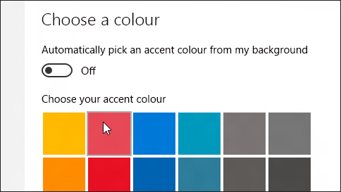

The Action Centre - Taking action instantly
Action Centre puts important notifications from Windows and your apps right on the taskbar, along with quick actions, which get you to your most-used settings and apps instantly.
To see your notifications and quick actions, select the Action Centre icon on the taskbar. (You can also swipe in from the right-hand edge of your screen, or press Windows logo key +A.)
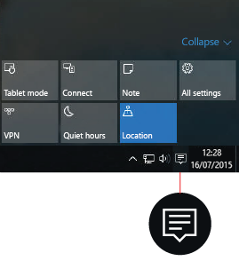

Notifications at a glance
When a notification appears on your desktop or when you view it in Action Centre, expand it to read more or take action – such as replying to an email – without having to open the related app. Don't want to take any action? Clear the notification by selecting and dragging it off screen to the right, or by selecting the close button.
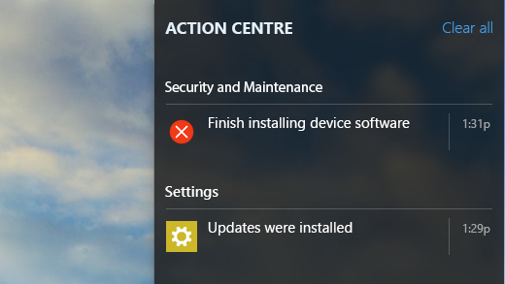

Make it snappy
Quick actions take you straight to (or turn on or off) the settings and apps you're likely to use often, from Bluetooth to brightness. When you open Action Centre, you'll see all your available quick actions. Collapse them to see only your top four picks.
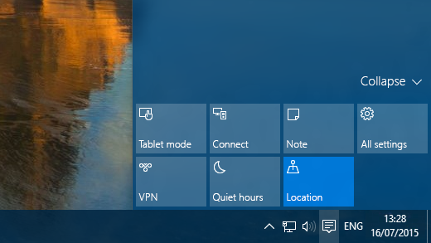

Pin it
Pin apps to the Start menu to see live updates on what's happening in your world, such as new emails, your next appointment or the weekend's weather. When you pin an app, it's added to the Start menu as a new tile.

Pinning apps to Start
- Select the Start button then select All apps .
- Press and hold (or right-click) the app that you want to pin.
- Select Pin to Start.
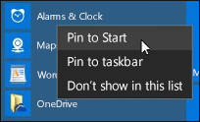
Once you pin a new app, resize it. Press and hold (or right-click) the app tile, select Resize, then choose the tile size you want.

Tip: Drag and drop apps from the Most used list or from All apps to pin them to the Start menu as tiles.

Group your apps
After you've pinned an app, move it into a group.
To create a new group of tiles, move an app's tile up or down until a group divider appears, then release the tile. Move apps in or out of the group as your fancy takes you.
To give your new group a name, select the open space above your new group and type a name.

Making “Start” full-screen
To make Start full-screen and see everything in one view, select the Start button, then select Settings > Personalisation > Start, then turn on Use Start full-screen.
Select the Menu in the top left-hand corner of the screen to get to your account picture, the All apps and Most used list, and the power button.
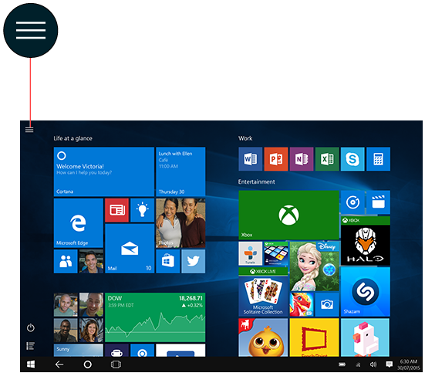
If you just want to resize the Start menu a bit to make it taller or wider, select the top or side border and drag it.

Getting to know Microsoft Edge
Microsoft Edge gives you new ways to find things, read – and write – on the web. To get going, select Microsoft Edge on the taskbar.

Hub*: all your stuff in one place (*the three horizontal lines!)
Think of the Hub as the place where Microsoft Edge keeps the things that you collect on the web. Select Hub to view your favourites, reading list, browsing history and current downloads.
Looking for your favourites? In the Hub, choose Favourites, then select Import favourites.

Search faster from the address bar
No need to go to a website to search for pictures of adorable penguins. Stay put and save time by typing your search in the handy address bar. You’ll get search suggestions, instant results from the web, and your browsing history right where you are.
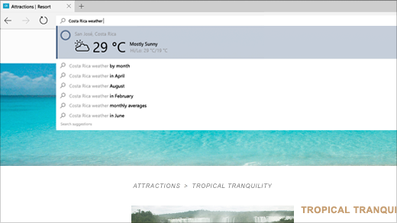
Top of Form

Writing on the web
Microsoft Edge is the only browser that lets you take notes, write, doodle and highlight directly on web pages. Then you can save and share your handiwork in all the usual ways. Make notes on recipes, send “subtle hints” about birthday gifts, or just draw moustaches on celebrities – the web is your canvas.
Select Make a web note to start adding to the page you’re on.
Use the Pen to write with your touchscreen or mouse, Highlight or Type a note, then Share it.
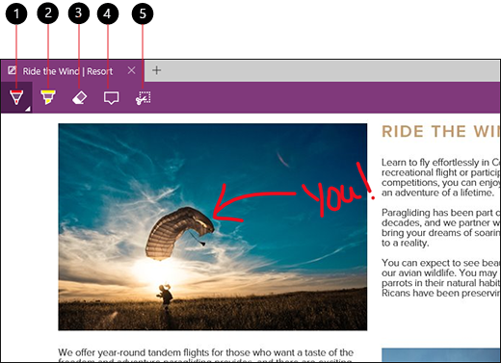
1. Pen 2. Highlighter 3. Eraser 4. Add a typed note 5. Clip

Reading View
Edge includes a “reading view” that strips the clutter from articles you find on the web and makes them more easily readable. To activate this, just find an article on the web and click or tap the “reading view” icon in the address bar. The icon looks like a book.

Reading List
Microsoft Edge includes a reading list feature, too. Use this to save articles you want to read later without cluttering your favourites list. To do this, just click or tap the star icon on the address bar. Select the Reading list heading and add the page to your reading list.

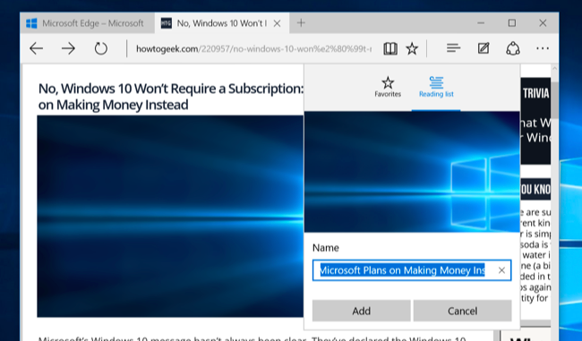
Access your reading list later by clicking or tapping the “hub” button and selecting the Reading List category. You’ll see pages you saved to read later, stored separately from your normal favourite web pages.

Sharing Web Pages
The Edge browser has a Share button (shown as a circle with three dots on it) on its toolbar. Tapping the Share button will open the system Share panel. You can share by installing the appropriate apps from the Windows Store.
For example, if you want to share on Facebook, install the Facebook app. If you want to share on Twitter, install the Twitter app. This provides you with an easy way of sharing web pages. You can also tap the title of the page in the Share panel and choose to share a screenshot of the current web page rather than a link to it.

